Insurance Claims- Fraud Detection
I Did A Project On One Of The Most Important Cases In The Real-life World-that Is Insurance Fraud Detection Using Machine Learning. Insurance Claims Frauds Result In Many Financial Losses To The Company Offering Insurance.This Problems Needs To Be Solved With As Minimum Losses As Possible To The Company.Machine Learning Provides A Great Solution Due To Its Prediction Ability To Figure Out Whether There Will Be Fraud Or Not Depending Upon The Type Of Customer,Accident Type,Premium Amount And Many Other Relevant Factors.My Task Was To Make The Best Machine Learning Model As Possible To Clearly Detect Whether There Will Be Fraud Claims Or Not In The Future.

A Model Which Classifies A Good Claim As Fraud Is Not A Big Issue But A Model Classifying A Fraud Claim As A Good Or Normal Claim Is A Huge Mistake And Can Lead To Huge Financial Losses To The Company.

1.Problem Definition:
Insurance Fraud Is A Huge Problem In The Industry. It's Difficult To Identify Fraud Claims. Machine Learning Is In A Unique Position To Help The Auto Insurance Industry With This Problem.
In This Project, I Am Provided A Dataset Which Has The Details Of The Insurance Policy Along With The Customer Details. It Also Has The Details Of The Accident On The Basis Of Which The Claims Have Been Made.
In This Example, I Will Be Working With Some Auto Insurance Data To Demonstrate How I Can Create A Predictive Model That Predicts If An Insurance Claim Is Fraudulent Or Not.
I Have To Predict Whether There Will Be Fraud Or Not.It Is A Classification Task.

2. Data Analysis
I Imported The Necessary Libraries For Data Cleaning And Analysis Like Pandas,Numpy,Matplotlib And Seaborn.I Checked For Missing/Null Values And There Is 1 Full Column With Missing Values --->_c39.I Explored Various Statistical Information Regarding Both Numerical Data Type Columns And Object Data Type Columns.I Created The Histograms For Each Of The Numerical Columns And Used Pandas Groupby Functions To Derive Information From The Datasets.I Plotted The Skewness Of The Data.

I Plotted Skewness For All Data Distributions Against Columns Of The Data. Plotted Green Horizontal Line For A Skewness Of Zero(Normal Distribution Has A Skewness Of 0). Plotted Red Lines Around The Green Line Denoting A Range Of(-0.5,0.5). If Data Points Fall Within The Above Mentioned Range,Then They Are Approximately Normally Distributed .
The Rule For Skewness Seems To Be: If The Skewness Is Between -0.5 And 0.5, The Data Are Fairly Symmetrical. If The Skewness Is Between -1 And -0.5 (Negatively Skewed) Or Between 0.5 And 1 (Positively Skewed), The Data Are Moderately Skewed.I Also Plotted Correlation For The Numerical Columns Of The Dataset To Know The Relationship Between Them.I Calculated Chi-square Test To Know The Relationship Between Categorical Columns Of The Dataset.I Removed 2%Of The Data Because They Were Declared Outliers Using Z-score Standardization Method.I Checked The Distribution Of The Target Label(The Value To Predict) And I Found That Dataset Is Highly Imbalanced Meaning The Dataset Is Having More And More Counts Of 1 Class Than The Other.I Used The Oversampling Technique For The Minority Class Called Smote Method To Balance The Dataset.

3.Exploratory Data Analysis(Eda) Concluding Remarks:-
- There Was 1 Full Column With Missing Values --->_c39,So I Removed It.
- The Column With Missing Values Is Now Removed,So Now There Are 1000 Rows And 39 Columns.
- Males Taking An Insurance Policy Have A Higher Chance Of Committing Fraud.
- Customers With Policy State-oh Has The Highest Chance Of Doing Fraud.
- Customers With Policy Csl-250/500 Has The Highest Chance Of Doing Fraud.
- Insured With Education Of Phd Has The Highest Chance Of Doing Fraud.
- Insured With Occupation Of Exec-managerial Has The Highest Chance Of Committing Fraud.
- Customers With A Single Vehicle Collision Incident Have A Higher Chance Of Doing Fraud.
- Insurance Claims Involving Police Reports Have The Lowest Chance Of Fraud.
- Insurance Claims Involving No Property Damage Have The Lowest Chance Of Fraud.
- Insurance Claims Regarding Incidents Involving Bodily Injuries-2 Have The Highest Chance Of Involving Fraud.
- Insurance Claims Involving Incidents Of Major Damage Have The Highest Rate Of Fraud.
- Insurance Claims With Incidents Involving The Number Of Vehicles 4 Have The Highest Chance Of Involving Fraud.
- For The Customers At The Age Of 40,I Can See That The Number Of Frauds Is Quite High.
- The Column-->Policy_number Is Unique Or Distinct For Every Row Of The Dataset.
- I Dropped The Policy_number Column Because It Is Unique For Every Customer Like His/Her Name In The Insurance Records.
- Insured_zip Is The Zip Code Of The Insured Location.
- Incident Hour Is A Time Hour Column
- The Number Of Vehicles Involved In The Column Has 4 Unique Values.
- The Bodily Injuries Column Has 3 Unique Values.
- 'witnesses' Column Has 4 Unique Values.
- The Most Number Of Counts For Every Column Named In Above List Is Around:
- 'months_as_customer'-100
- Age-40
- 'policy_deductable'-1000 And 1200
- 'policy_annual_premium'-1400
- 'umbrella-limit'=0.0
- 'capital-gains'=0 And Before 20000 And It Is A Rightly Skewed Data Distribution.
- Capital-loss=0.0
- Total Claim Amount=60000
- Injury Claim-5000
- Property_claim-5000
- Vehicle_claim-40000 And 50000
- Insured With Hobbies -->Chess Has The Highest Chance Of Doing Fraud.
- Umbrella-limit,Total_claim_amount And Vehicle_claim Are Highly Skewed.I Am Not Considering Categorical Columns.
- There Are Many Variables Having Strong Positive Correlation Among Them:--
- Months As Customer And Age
- Total Claim Amount,Injury Claim,Property Claim And Vehicle Claim.
- Positive Correlation Is A Relationship Between Two Variables In Which Both Variables Move In The Same Direction.
- A Positive Correlation Exists When One Variable Decreases As The Other Variable Decreases, Or One Variable Increases While The Other Increases
- There Is No Strong Negative Relationship Between Any Columns Of The Data.
- Negative Or Inverse Correlation Describes When Two Variables Tend To Move In Opposite Size And Direction From One Another, Such That When One Increases The Other Variable Decreases, And Vice-versa.
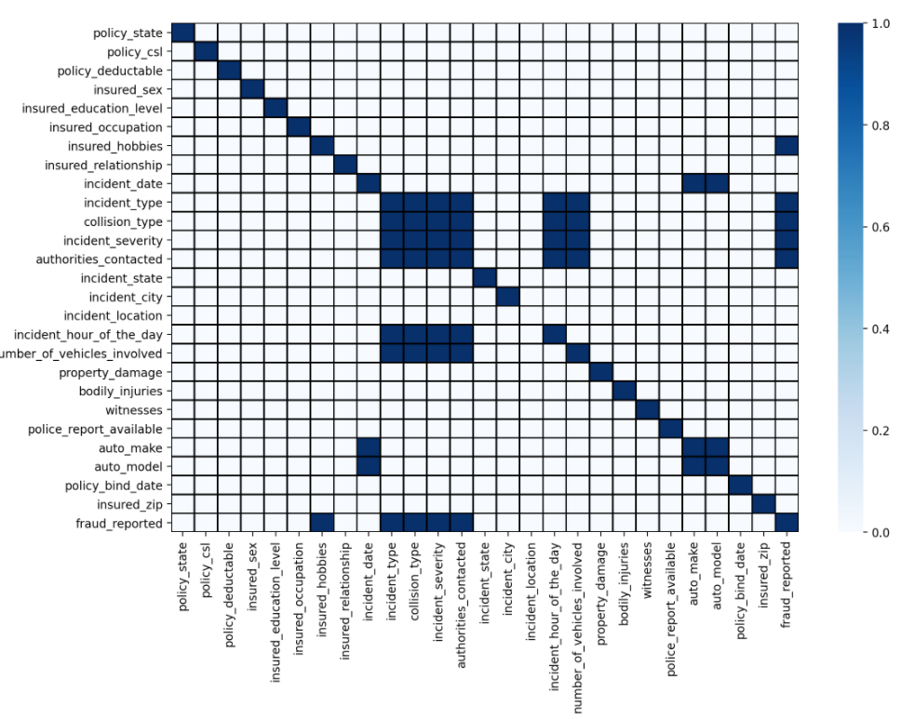

As Shown In The Above Heatmap Figure,The 'blue' Colour Shows The Relationship Status To Be 'yes' Or (1),Whereas The 'white' Colour Shows The Relationship Status To Be 'no' Or (0) Between The Variables Of The Dataset.

- I Encoded All The Categorical Columns Of The Dataset And Also 'incident_hour_of_the_day','witnesses', 'number_of_vehicles_involved', 'bodily_injuries', 'insured_zip'.
- 2% Of The Data Has Been Removed Because They Have Been Declared Outliers.
- I Used The Cube Root Function To Try To Reduce The Excess Skewness For The Umbrella Limit.
- Excess Skewness Removal Is Necessary,But It Has Not Been Removed For Umbrella Limit,Vehicle Claim And Total Claim Amount.
- I Did Not Remove Skewness For The Encoded.Categorical Columns Or Object Columns.
- 0 Is For 'no' And 1 Is 'yes' In The 'fraud_reported' Column.
- The Dataset Is Highly Imbalanced With The Target Label 'churn' Distributed More Towards 'no'(740) And Less Towards 'yes'(240).
- I Used The Smote Method From Imblearn Library To Oversample The Minority Class.
- I Was Not Able To Reduce The Skewness For Umbrella Limit,Vehicle Claim And Total_claim_amount,So I Used A Power Transformer To Help In My Skewness.
- I Found That Every Column Skewness Was Improved Except Umbrella Limit Skewness Worsened. So I Did The Power Transformer For X Without A Column -->Umbrella Limit.
- I Created A New X Dataframe Named Final_x By Combining X Without An Umbrella Limit Column And An Umbrella Limit Column Separately.
- I Created A New Data Frame Of Final_x With The Number Of Components-->4 Using Principal Component Analysis(Pca) After Checking The Explained Variance Ratio To Finalize The Number Of Components.

4.Preprocessing Pipeline
I Imported The Pipeline Object From The Sklearn Library. I Created A Pipeline For Standard Scalar Function And Also For Each Model Used In Fitting And Testing The Data.I Used The Pipeline Along With Gridsearchcv To Find The Best Parameters For My Model Based On The Performance Metrics.
5.Building Machine Learning Models
This Is A Classification Task And I Have To Predict The Fraud(Yes Or No).
I Seperated My Features(X) Data And Target Label(Y) Being Fraud'(Yes Or No).
I Imported The Necessary Libraries And Metrics For Classification Tasks From Sklearn Library.
I Imported The Models Like-
- Logistic Regression,
- Support Vector Classifier,
- K-nearest Neighbors,
- Decision Tree Classifier,
- Random Forest Classifier,
- Ada Boosting Classifier,
- Gradient Boosting Classifier
- Light Gbm Classifier

I Imported The Performance Metrics And Scores Like-
- Accuracy Score
- Precision Score
- Recall Score
- Classification Report
- Confusion Matrix
- Plot-confusion Matrix
- Auc-roc-curve
- Auc-roc-score
If I Fit The Data Frame Final_data_x Created Using Principal Component Analysis(Pca) And Power Transformer And Then Train The Model,Then My Model's Maximum Accuracy Is Around 65%.
If I Fit The Data Frame Created After Power Transformer Only And Train The Model,Then My Model's Maximum Accuracy Is Around 84%.
If I Fit The Data Frame X_over Without Pca And Power Transformer And Train The Model,Then My Model's Maximum Accuracy Is Around 85%.
I Did The Train-test Split For The Dataset Using Random State 35 And Test Data Size 30%.The Training Data Was 70% Of The Whole Data And Testing Was 30% Of The Data.For Standardisation And Scaling Purpose,I Imported The Standard Scalar Method From ‘sklearn’ Library.
Only Training Data Has Been Both Fit And Transformed But The Test Data Has Only Been Transformed. '.Fit' Means Calculating Necessary Statistics From The Data And '.Transform' Only Scales The Data. Test Data Should Not Be Fit Because That Would Lead To Assumption Of The Prior Knowledge Of The Test Data And Test Data Is The Data, Machine Learning Model Need To Predict Fairly Without Having Any Knowledge Of The Test Data.
I Used Every Model Imported (As Mentioned Above) For Fitting The Training Data And Then Predicting My Target Variable. I Compared The Performance Of All The Models With Actual Test Data Of Y Using The Metrics And Scores I Imported(As Mentioned Above).
6.Concluding Remarks

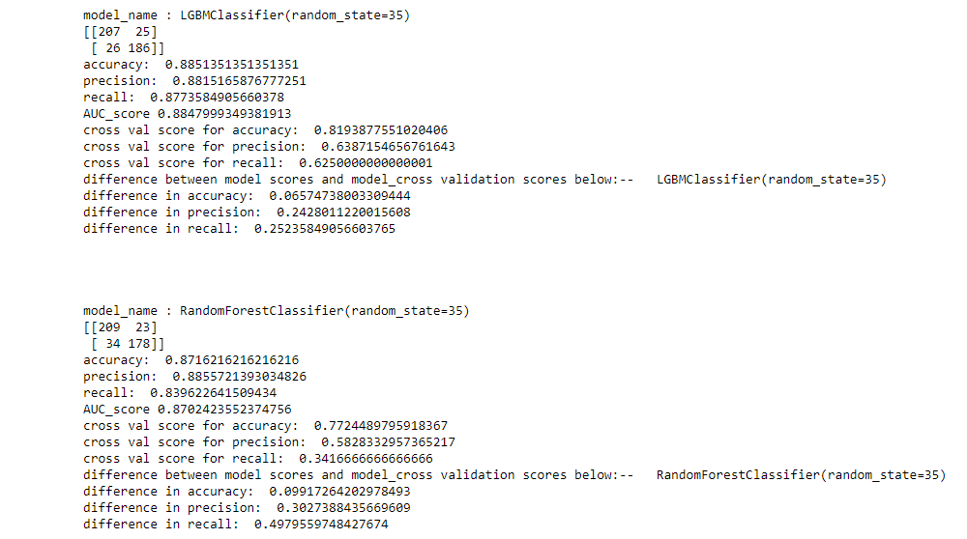
Random Forest Classifier And Light Gbm Classifier Performed The Best Among All The Models Based On The Metrics And Scores.
They Were Chosen For Hyperparameter Tuning With Grid Search Cv To Find The Best Parameters For Best Classification.
Difference In Cross Val Score -accuracy And Accuracy Score Is The Criteria For Choosing Random Forest Over Gradient Boosting Classifier.
I Used A Pipeline For All Those Good Models For Finding The Best Parameters From Grid Search Cv.
I Used A Light Gbm Classifier Because It Is Very Fast Compared To Gradient Boosting Classifier ,Ada-boosting Classifier And Also Random Forest Classifier.
I Can Say Among All The Models That I Imported,Light Gbm Classifier Is The Fastest.

Accuracy Score Is Not A Good Score For Showing Model’s Performance Because It Fails To Show True Model’s Performance If My Data Is Not Balanced Or If The Data Contains More Of 1 Class Than The Other By A Fairly Large Gap. In This Case, My Data Was Imbalanced,So I Used A Smote Method For Oversampling The Minority Class.
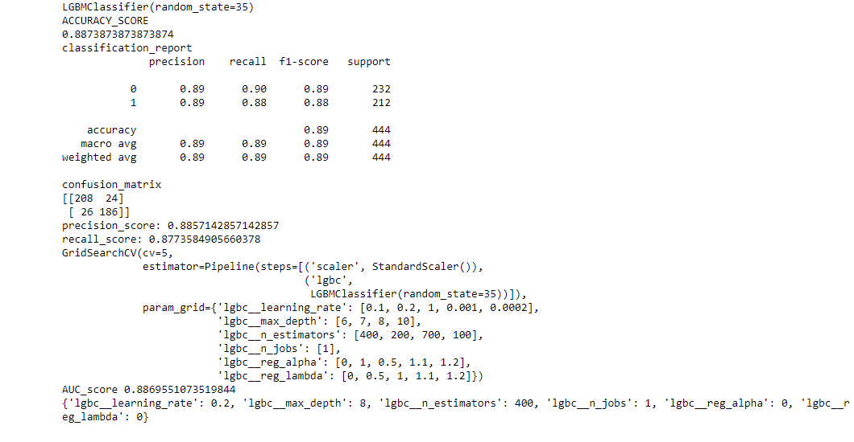
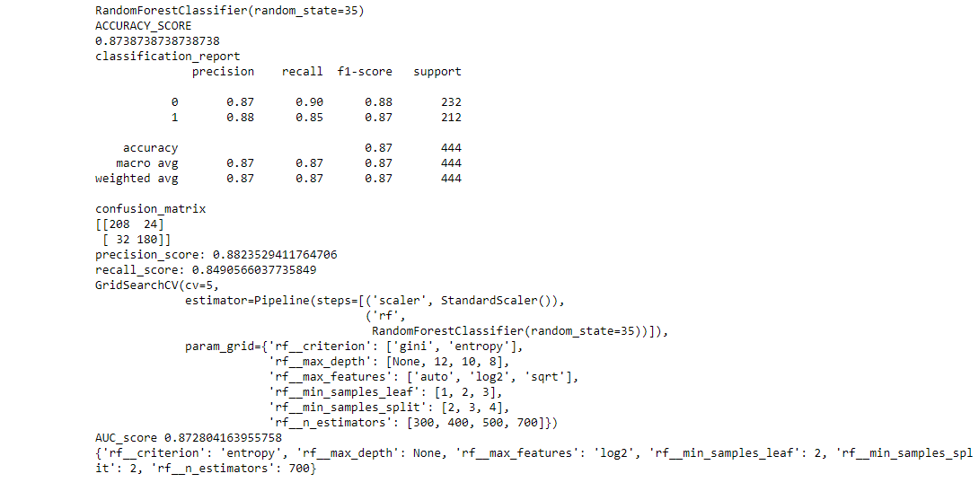
I Found The Best Parameters For Both The Random Forest Classifier And Light Gbm Classifier Using Grid Search Cv But Light Gbm Classifier Performed The Best With Higher Scores And Metrics As Shown Above.
Random Forest Classifiers Never Overfit Or I Can Say They Have The Minimum Chances Of Overfitting Among All The Models that I imported from sklearn library.

Light Gbm Classifier Based On Grid Search Cv Had The Better Auc-roc Score --- Around 88.69% (Misclassifying 24+26=50 Instances) Than Random Forest Classifier Which Had A Auc-roc Score Of Around--87.28%(Misclassifying 24+32=56 Instances).
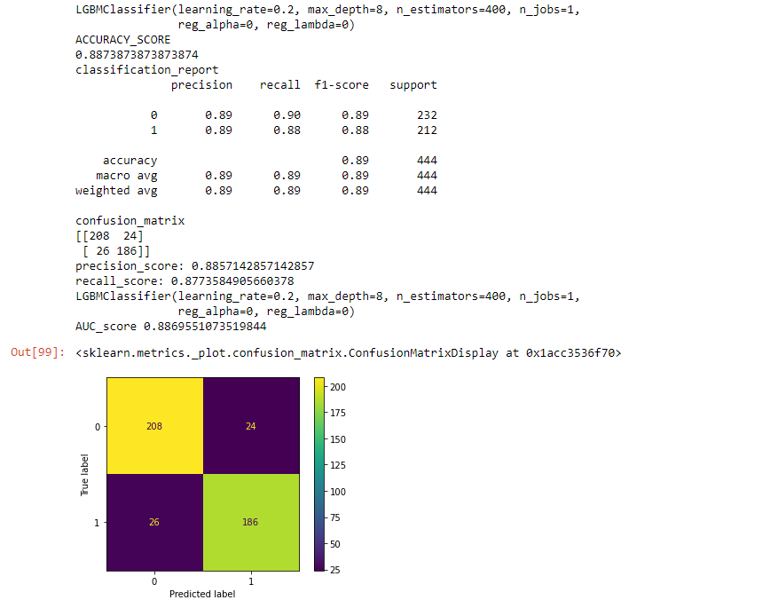
0 Is For 'no' And 1 Is 'yes' In The 'fraud_reported' Column.
I Used The Best Parameters Found From Grid Search Cv To Create The Model For Light Gbm Classifier.
My Above Created Model Misclassifies 50 Counts Of Data.
However,It Misclassified 26 Which Are Actually Fraud Claims As Good/Normal And Misclassified 24 Which Are Actually Normal Or Good Claims As Fraud.
I Imported Joblib Library To Save The Model And Dump It.

